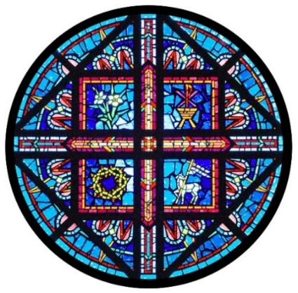
HOLY INFANT
Parish School of Religion
Parent Handbook 2026-2027

248 New Ballwin Road, Ballwin, MO 63021
Phone: 636-227-0802 Option 3
faithformation@holyinfantballwin.org
psroffice@holyinfantballwin.org

Mission Statement
PSR aims to educate and form students in our faith by preparing them for the reception of the sacraments as well as provide experiences of Catholic community, service, and worship throughout the year. With the grace of the Holy Spirit, we strive to educate our children and families in the Catholic faith, assist parents in forming their children’s ongoing spiritual development, and be an instrument in transforming their hearts to love God more and more.

Family Witness
"Family catechesis precedes, accompanies, and enriches other forms of instruction in the faith. Parents have the mission of teaching their children to pray and to discover their vocation as children of God. The parish is the Eucharistic community and the heart of the liturgical life of Christian families; it is a privileged place for the catechesis of children and parents."
(Catechism of the Catholic Church #2226)

It is our mission to promote lifelong relationships with Christ and his Church for children and their families. In order for this program to serve its mission, we invite all families to join us in the liturgical and social life of the parish!

- Participation in the mass each Sunday is both essential and expected of all students and parents in the PSR program. The goal of religious education is to bring all people into close friendship with Christ. As Saint John Paul II said, “The Eucharist is the secret of my day. It gives strength and meaning to all my activities of service to the Church and to the whole world.”
Sunday mass times at Holy Infant:
Saturday: 4 p.m., 5:30 p.m.
Sunday: 7 a.m., 8:30 a.m., 10:15 a.m. and noon
- Teach by word and example how to love others, tend to others’ needs, and support the moral and social teachings of the Catholic Church.
- Receive the sacraments, especially Reconciliation at least once a year.
- Commit to speak more with your children about God and pray together. Below are some resources to help.

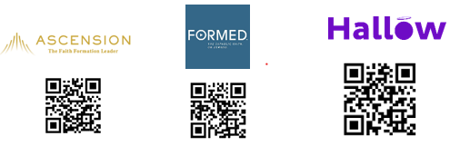
ATTENDANCE POLICY

CLASS TIME: Mondays, 4:30-5:40 p.m.

Attendance at all classes and activities is expected unless parents provide timely notification for each excused absence. Because of the limited number of sessions, every session is important, especially for students preparing to receive a sacrament. While we understand that family events will mean an occasional missed session, these should be kept to a minimum. Make-up lessons can be obtained from the catechist. He/she will be more than willing to keep your child up to date assigning reading or homework assignments. It is the parent’s and student’s responsibility to follow up and complete all missed work.

To report an absence, please call the PSR Office at 636-227-0802 Option 3 ext.137 or email us at psroffice@holyinfantballwin.org. Leave your child’s name, grade, session, and the reason for the absence. Please also alert your child’s teacher.

TARDIES: Arrivals after 4:40 p.m. are considered tardies. If you are arriving late, please walk your child all the way to the PSR office.

EARLY RELEASE: There may be times when it will be necessary to pick up your child earlier than our scheduled release time of 5:40 p.m. If you know your child will be leaving early:
- Send an email to the PSR Office (psroffice@holyinfantballwin.org) along with an email to your child’s teacher or a note for your child to give to the teacher indicating the time you will be picking him/her up and the reason why.
- If someone else is picking up your child, write a note or email to PSR indicating who will pick them up. We cannot release your child without this written permission.
- Each parent must come to the PSR Office to sign your child out.

INCLEMENT WEATHER POLICY
We do not cancel PSR classes based on what another school district may do. If bad weather occurs on a class day and we need to cancel classes, a message will be placed on the answering machine in the PSR Office. We will put a message on TV Channels 2, 4 and 5. Emails will also be sent out.

REPORT CARDS
Students will receive report cards twice a year. Dates will be listed in the PSR calendar, so parents know when to expect them. If you need to schedule a conference, this can be arranged with your child’s teacher.

DISCIPLINE POLICIES
Our Parish Religious Education Program encourages growth in responsibility. In all our actions dealing with students, we must show a deep respect and concern for one another. Students are expected to exercise self-control, to conduct themselves with Christian dignity, and to be polite to all adults and students. Students must respect the authority and the efforts of the adults in the building, as well as the right of their fellow students to receive the full benefit of the classroom lessons without rude distractions.
The day-to-day discipline of the class will be handled by the catechist. Disruptive behaviors include:
  - use of cell phones in the classroom
  - sustained or excessive show of disrespect for the teacher or other students
  - controllable behavior which repeatedly distracts the other students or the catechist from the lesson.
If disruption in the class is continuous or becomes serious, the student will be sent to the Director of Religious Education. She will speak with the student and a notice will be sent home to the parents. If this happens a second time, the Director will contact the parents by phone. If a third offense takes place, the student is suspended until a conference is held with the parents, the catechist, and the Director.

OTHER POLICIES
Safety
We take each child’s safety very seriously. All catechists, classroom aids, and child caretakers must be compliant with Safe Environment Program called “Prevent and Protect.” Catechists will walk your children to the parking lot at dismissal.

Gum, Candy, and Snacks
No gum chewing, eating of candy or other food or drink is permitted unless it is provided by the catechist or staff for a particular class event. Please contact the Director of Religious Education if there is a medical need.

Respect for Property and Others
We are stewards of the building so we ask that all students respect the premises, personal property of others, as well as materials the catechist may distribute to students. No books or items are to be removed from the desks. Classroom furniture and materials must be returned to their original location.

Dress Code
Students are expected to dress and present an appearance consistent with standards of good taste and appropriate for the Parish School of Religion (modesty). Any dress or wearing of insignia which conveys messages in conflict with Catholic belief are not allowed. Baseball caps and hats of any kind are not to be worn in Church.

Electronics Policy
Headphones, cell phones, and other electronic devices are not to be used or displayed during class time. Cell phones must be silenced. Abuse of this will result in the items being sent to the Office to be picked up after dismissal.

Communication
The PSR staff is committed to communicating with parents to assist you in the religious formation of your child. Please check with your child after each class for any notes or other information being brought home. Please read the weekly PSR newsletter and the Parish flocknotes. If you are not receiving emails from our PSR program, please reach out to ensure we have the correct email on file.

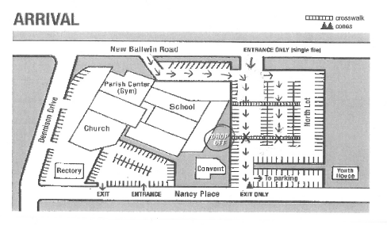
STUDENT ARRIVAL/DISMISSAL

Arrival:
It is required that you use New Ballwin Road entrances (by the marquee sign and the North parking lot). Proceed to the stop sign by the white painted lines on the parking lot. Pull up as far as possible so there will be no back-up on New Ballwin Road. There should only be one row of traffic coming into the parking lot from each New Ballwin entrance. Exit onto Nancy Place. To park, make a left turn in the parking lot.

Dismissal:
The purpose of these guidelines is to ensure the safety of students on the parking lot while being dismissed. Students and cars should never be moving on the parking lot at the same time. Your support and patience is greatly appreciated.

Do not park in front of the Church, pick up from a side street, or pick up from any other lot than the North lot. Park only in a designated parking space.

The parking lot closes at 5:35 p.m. Orange cones will be placed at the lot entrances to close them off. Please back into your assigned space (except those parking in spaces 109 – 131 will pull in).

Students will be dismissed from school at 5:40 p.m. and will walk to their cars. Parents of 3rd – 8th graders are asked to stay in their vehicles. Parents of K – 2nd graders may park and come to the sidewalk by the school building to pick them up.

Once all students are in their vehicles and the lot is cleared of all pedestrian traffic, cars will be dismissed by a teacher or committee member. Do not move until dismissed.
New Ballwin Road Lot Dismissal (parking spots # 1 – 206)
Carpools exiting onto New Ballwin will form two lanes: the left lane for southbound traffic and the right lane for northbound traffic. Orange cones will divide the New Ballwin exit into two lanes.

Carpools exiting onto Nancy Place will turn left off of the lot and exit out onto Old Ballwin. No one may turn right onto Nancy Place.

Carpools not ready to leave at this time should remain parked and motion the other drivers to go ahead. If a child in your carpool did not come out, drivers must remain on the lot until the lot has cleared. Pull your car towards the main doors, park, and the driver MUST come into the upper cafeteria and sign the students out.

New Ballwin Road Lot – ORDER OF EXITING:
- Nancy Place: Row 10 #35-26, Row 10 #59 – 62, Row 8 #188 – 171, Row 9 #189-206
- Right on New Ballwin: Row 3 #63-85, Row 4 #108-86, Row 5 #109-131, Row 6 #147-132
- Left on New Ballwin: Row 2 #36-58, Row 7 #170-160, Row 6 #159-148, Row 1 #25-3

Late for Dismissal
- Drivers who have missed dismissal should pull into the waiting area in front of the upper cafeteria facing New Ballwin Road near the flagpole by entering by the Holy Infant Parish marquee sign.
- Orange cones will be placed across the lot where cars are to stop and wait.
- Students may enter their car in this lane. However, the car must wait to exit until the parking lot is emptied and the cones have been removed.

Additional Items
- Students will not be allowed to walk from one lot to the other – they will be directed back to the upper cafeteria for Late Dismissal.
- Please make sure that students are aware of any change in their dismissal so that they may exit directly to the correct lot/spot.
- Parents should not offer transportation to students who are not their own without first contacting the other parents, who, in turn, should notify the office of the change in plans.
- Please make sure that grandparents, older siblings, and others who don’t normally pick up at dismissal understand and follow the procedures.

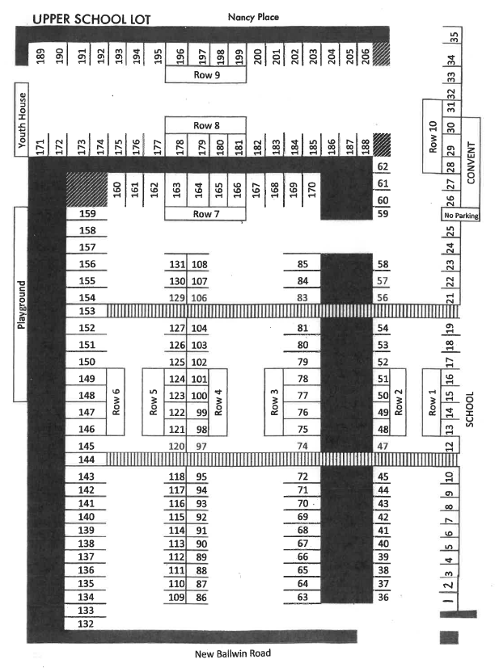
PRIVACY POLICY
Holy Infant understands that students/parents have access to technology that enables them to record, either visually or audibly, a student at the school or a member of the school staff.
Out of respect for the students in our school, students and parents are not to publicly post any videos, pictures, or audio recordings of students at school events unless the student/parent(s) have the express written permission from the school to do so. This includes, but is not limited to, online photo-sharing and posting videos to YouTube or similar applications.
Additionally, in order to ensure the privacy of members of the school staff, students and parents are not to record a member of the school staff without the express permission of the staff member. As such, students and parents are prohibited from recording classroom lessons/discussions and are prohibited from photographing or videotaping teachers without the teachers’ permission. Likewise, students and parents shall not publicly post any videos, pictures, or audio recordings of staff members unless the student/parent(s) have the express written permission from the school staff member. This includes, but is not limited to, online photo-sharing and posting videos to YouTube or similar applications.

PHILOSOPHY OF SERVICE
Service to others is an integral part of our Catholic faith and, therefore, is an important part of our catechesis. A desire to serve others and work for justice should be instilled in the students through each year of the PSR program. At each grade level, students will have age-appropriate opportunities to grow in knowledge, experience, and appreciation of Christian service and social justice. All students are also encouraged to participate in service activities outside of the PSR class setting on an on-going basis.

